MATH AND TRIG FUNCTIONS
Input data:
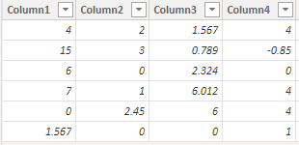

1)CONVERT: By using this we can convert one datatype to another data type.
Syntax: CONVERT(<Expression>, <Datatype>)
NOTE: <Datatype> includes Integer, Double, String, Boolean, Currency and Datetime.
Dax Function: 1) Convert_Bollen = CONVERT(Mathematical_exp[Column1],BOOLEAN)
2) Convert_string = CONVERT(Mathematical_exp[Column1],STRING)
3) Convert_Currency = CONVERT(Mathematical_exp[Column1],CURRENCY)
4) Convert_Bollen = CONVERT(Mathematical_exp[Column1],DATETIME)
5) Convert_Double = CONVERT(Mathematical_exp[Column1],DOUBLE)
6) Convert_Integer = CONVERT(Mathematical_exp[Column1],INTEGER)

Output:

1) 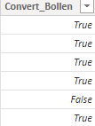 2) 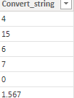

2)CURRENCY : By using this to display the resulat as Currency Datatype.
Syntax : CURRENCY(<value>)
Dax Function: Currency = CURRENCY(Mathematical_exp[Column2])

Output:
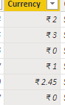
3)DIVIDE: Performs division and returns alternative result or BLANK() on division by 0.
Syntax: DIVIDE(<numerator>, <denominator> [,<alternateresult>])
NOTE: <alternative result> includes by default value is BLANK (), and also, we can mention alternativevaluse also in the place of “alternative value “.
Difference between normal division and in dax Divide is, in normal division when division by 0, retuns the result is undefined value, this result could not sufficient that’s why we can rectify this issue we can use “DIVIDE” function, this will be return “Blank ()” value, and also, we can mention a value also in the place of Blank ().
Dax Function: Divide = DIVIDE(Mathematical_exp[Column1],Mathematical_exp[Column2])
Output:
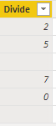
4)EVEN: It returns next nearest even number.
NOTE: By using this we can display the in the place of even display same even number and in the place of odd number, it returns as roundup to the nearest even integer.
Syntax: EVEN (number)
Dax Function: Even = EVEN(Mathematical_exp[Column2])
Output:
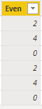
5)ODD: It returns next nearest odd number.
NOTE: By using this we can display the in the place of odd display same odd number and in the place of even number, it returns as roundup to the nearest odd integer.
Syntax: EVEN (number)
Dax Function: Even = EVEN(Mathematical_exp[Column2])
Output:
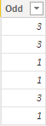
6)POWER: By using this to perform the power of the given number.
Syntax: POWER(<number>, <power>)
NOTE:<power> in the place mention any number (0,1,2,3….)
Dax Function: Power = POWER(Mathematical_exp[Column2],2)
Output:
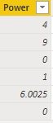
7)ROUND: Round function will round a number to the given number of digits.
NOTE: By using this the specified number of digit value is >=5, at that time 1 will be added to the specified number digit value.
Syntax: ROUND(<number>, <num_digits>)
Dax Function: Round = ROUND(Mathematical_exp[Column3],1)
Output:
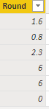
8)ROUNDUP: Roundup will round a number to next integer value if num_digits=0.
//NOTE : By using this the specified number of digit value is whatever may be, on that time directly will be added to 1 to the specified number digit value.
Syntax: ROUNDUP(<number>, <num_digits>)
Dax Function: Round Up = ROUNDUP(Mathematical_exp[Column3],0)
Output:
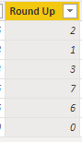
9) ROUNDDOWN: Rounddown round a number down, toward zero.
//NOTE : By using this the specified number of digit value is whatever may be, on that time same value means will be displayed.
Syntax: ROUNDDOWN(<number>, <num_digits>)
Dax Function: Round Down = ROUNDDOWN(Mathematical_exp[Column3],0)
Output:
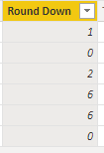

10)TRUNC: By using this we can display the before decimal part of the number.
Syntax: TRUNC(<number>,<num_digits>)
NOTE: In this we can’t do that any round functions
INT and TRUNC functions will give same result. I mean will perform same functionlaties, but in TRUNC mention how many number digits we can remove, but in INT there is no mention number digits value.
Dax Function: Trunc = TRUNC(Mathematical_exp[Column3],0)
Output:
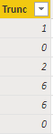

11) INT: By using this we can display the before decimal part of the number.
Syntax: INIT(<number>)
NOTE: In this we can’t do that any round functions
INT and TRUNC functions will give same result. I mean will perform same functionlaties, but in TRUNC mention how many number digits we can remove, but in INT there is no mention number digits value.
Dax Function: Int = INT(Mathematical_exp[Column3])
Output:
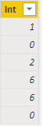

12)SIGN: By using this to find out the sign of a number,
NOTE: If the function returns 1 if the number is positive, returns 0 if the number is zero and return -1 if the number is negative.
Syntax: SIGN(<number>)
Dax Function: Sign = SIGN(Mathematical_exp[Column4])
Output:
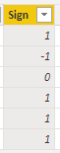

13)RAND: By using this to display the random number,
Syntax: RAND()
Note: The result always between 0 and 1.
Dax Function: Rand = RAND()
Output:
